INTRODUCTION

Nowadays, Wireless Sensor Networks (WSN) are widely been employed to solve agricultural problems related to the optimization of scarce farming resources, decision making support, and land monitoring. However, the small sensing devices that are part of WSNs – known as sensor nodes – suﬀer from degradation and so producing erroneous measurements. In this paper, a machine learning method based on Non-Negative Matrix Factorization (NMF) is applied to the spectral representation of data acquired by a WSN to extract features that model the normal behaviour of sensor node readings leading to a good representation of data using a low number of features. This procedure is accompanied by a classiﬁer that decides if there is a set of features that deviates from the normal ones. Experiments on soil moisture data show that NMF achieves good results detecting ﬂaws in readings from sensors. Results are compared with other method based on Principal Component Analysis (PCA), the Multiscale PCA (MSPCA) algorithm.

In these days, the development of methods to help to monitor the cultivation process in agriculture is a fundamental task. For example, monitoring variables such as the soil moisture is essential to control both the time and right amount of water to be supplied.

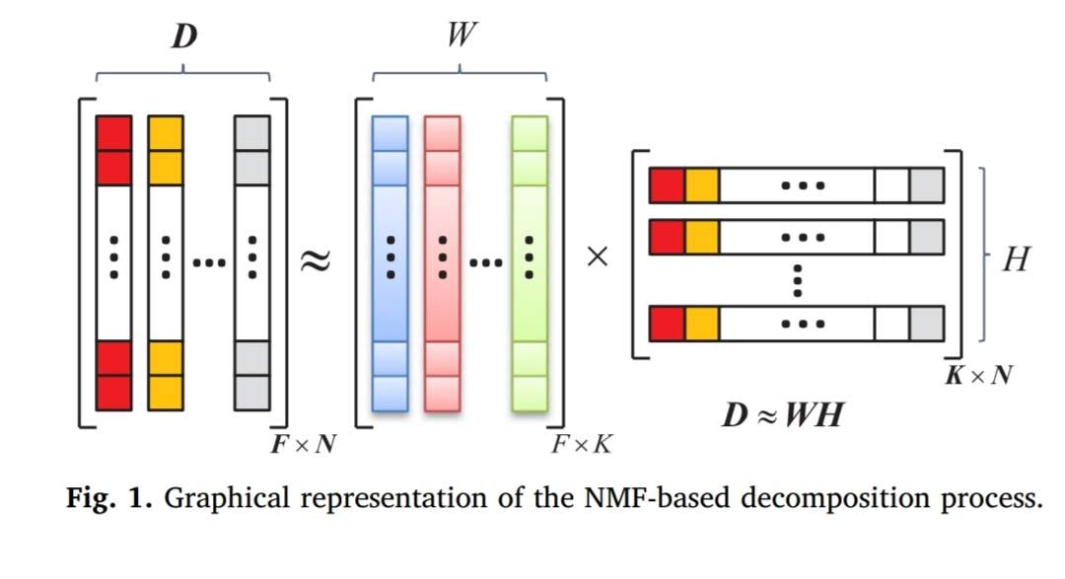

CONCLUSION

In this paper, an alternative method for feature extraction based on NMF to detect faults in soil moisture readings was presented. The system models the normal behavior of the sensor nodes from the spectral basis vectors obtained after applying the NMF algorithm over the spectral magnitude of the sensed data. From the SBVs, the activation coeﬃcients in Hs are updated to obtain a matrix of approximation error coeﬃcients (Es). Then, the sensor nodes are monitored using this matrix, enabling the system to determine which sensor nodes present wrong readings. The front-end has been tested using ﬁve types of faults artiﬁcially added to the test dataset. Presented results demonstrate that

obtained features are highly discriminative and allows to get low mean error probabilities using as Simple linear regressor or a SVM with a linear kernel. As well, it has been shown that results using the NMF-based method are comparable to those found by the MSPCA-based method. After comprehensive experiments, results show that NMF algorithm is a promising tool to detect ﬂaws in readings from sensor nodes, allowing to capture the most important and relevant spectral components from sensed data.

References

Ayadi, H., Zouinkhi, A., Boussaid, B., Abdelkrim, M.N., 2015. A machine learning methods: outlier detection in WSN. In: Sciences and Techniques of Automatic Control and Computer Engineering (STA), 2015 16th International Conference on. IEE, E, pp. 722–727. Bakshi, B.R., 1998. Multiscale PCA with application to multivariate statistical process monitoring. AIChE J. 44, 1596–1610. Chang, C.-C., Lin, C.-J., 2011. LIBSVM: a library for support vector machines. ACM Trans. Intell. Syst. Technol. 2, 27:1–27:27. Software available at<http://www.csie.ntu. edu.tw/cjlin/libsvm>. Chen, Z., Yeo, C.K., Francis, B.S.L., Lau, C.T., 2015. A MSPCA based intrusion detection algorithm tor detection of DDoS attack. In: Communications in China (ICCC), 2015 IEEE/CIC International Conference on. IEEE, pp. 1–5. Chen, Z., Yeo, C.K., Francis, B.S.L., Lau, C.T., 2016. Combining MIC feature selection and feature-based MSPCA for network traﬃc anomaly detection. In: Digital Information Processing, Data Mining, and Wireless Communications (DIPDMWC), 2016 Third International Conference on. IEEE, pp. 176–181. Chen, Z., Yeo, C.K., Lee, B.S., Lau, C.T., 2017. Detection of network anomalies using improved-MSPCA with sketches. Comput. Secur. 65, 314–328. Christopher, M.B., 2016. Pattern Recognition and Machine Learning. Springer-Verlag, New York. Cichocki, A., Phan, A.H., Zdunek, R., 2009.

A.ALEKHYA (17RH1A0413)

A.ALEKHYA

(17RH1A0413)